

A LOW-CODE FRAMEWORK FOR CONVERSATIONAL AI ASSISTANTS LEVERAGING RETRIEVAL-AUGMENTED GENERATION AND LLMs

PROJECT DISSERTATION II REPORT
Submitted by
THANIGAIVELG
Reg.No : 24880107
in partial fulfilment of the award of the degree of
MASTER OF ENGINEERING
IN
COMPUTER SCIENCE AND ENGINEERING DEPARTMENT OF COMPUTER SCIENCE AND ENGINEERING
SCHOOL OF ENGINEERING
VELS INSTITUTE OF SCIENCE, TECHNOLOGY & ADVANCED STUDIES(VISTAS)
PALLAVARAM, CHENNAI 600117

NOV 2025

BONAFIDE CERTIFICATE

Certified that this project “A LOW-CODE FRAMEWORK FOR CONVERSATIONAL AI ASSISTANTS LEVERAGING RETRIEVAL-AUGMENTED GENERATION AND LLMs” is the bonafide work of THANIGAIVEL G (24880107) who carried out the project under my supervision. Certified further, that to the best of my knowledge the work reported here does not form part of any other project report or dissertation on the basis of which a degree or award was conferred on an earlier occasion on this or any other candidate.

SIGNATURE SIGNATURE
Dr.K.KALAIVANI, M.E., Ph.D, Dr. N.Kumar M.Tech., Ph.D.,
Associate Professor, Professor,
Head of the Department, Supervisor,
Department of CSE, Department of CSE,
VISTAS, VISTAS,
Chennai – 600 117. Chennai – 600 117.

Submitted for the project work and viva - voice examination held on
…………… at Vels Institute of Science, Technology and Advanced Studies (VISTAS), Chennai – 600 117.

INTERNAL EXAMINER EXTERNAL EXAMINER

ACKNOWLEDGEMENT

It is certainly a great delight and proud privilege to acknowledge the help and support I received from the positive minds around me in making this venture a successful one. The infrastructural support with all kinds of lab facilities have been a motivating factor in this completion of project work, all because of FOUNDER & CHAIRMAN, Shri. Dr. ISHARI K. GANESH.,
with great pleasure that I take this opportunity to thank him. I am grateful to our

HEAD OF THE DEPARTMENT, Dr.K.KALAIVANI, M.E., Ph.D for her
continuous support for the project, from initial advice and contacts in the early stages of conceptual inception, and through on-going advice and encouragement to this day.

I extend our warmest thanks to my INTERNAL GUIDE, Dr.R.ANANDAN M.S, Ph.D., who has patiently guided and provided us with invaluable advice and help. I am thankful to my Project Coordinator Dr. N. KUMAR M.Tech., Ph.D., I would like to express my greatest gratitude to our staff members, librarian and non-teaching staff members of Computer Centre, who have helped and supported me throughout. Last but not the Least, I wish to thank my PARENTS and my friends for their individual support and interest who has inspired me and encouraged me to go in my own way, without them I would be unable to complete this project.

THANIGAIVEL G - 24880107

ABSTRACT

Conversational AI assistants have evolved rapidly with the rise of large language models (LLMs). However, developing customized assistants that integrate external knowledge, handle domain-specific queries, and maintain cost-efficiency still demands advanced programming skills. To address this, the proposed work introduces a low-code framework for building and deploying conversational AI assistants that leverage Retrieval-Augmented Generation (RAG) and LLMs.
The framework enables non-expert users to design intelligent dialogue systems through a drag-and-drop interface. Developers can connect components such as data ingestion, vector indexing, retriever, and LLM modules without extensive coding. A pipeline based on semantic retrieval augments the LLM context with relevant documents, enabling accurate and verifiable responses.
The proposed system combines a Low-Code Designer (for UI and workflow creation), a RAG Engine (for contextual retrieval), and an LLM Runtime (for natural-language reasoning and response generation). Tools such as LangChain, FAISS/Pinecone, FastAPI, and OpenAI/Hugging Face models are employed. Performance is evaluated using accuracy, latency, and usability metrics. The framework aims to democratize the development of advanced conversational agents.

TABLE OF CONTENTS

CHAPTER NO. TITLE PAGE NO. ABSTRACT iii

ACKNOWLEDGEMENT iv

LIST OF FIGURES ix

LIST OF ABBREVIATIONS x

1 | INTRODUCTION | 1
 | 1.1ANTISOCIAL PERSONALITY DISORDER | 1
 | 1.2 INTRODUCTION TO fMRI | 6
 | - How Does And fMRI Work?  - Advantages of using fMRI for detection of ADHD | 6  8
 | 1.3 EXISTING WORK | 9
 | 1.4 PROPOSED WORK | 9
 | 1.4.1 Objectives | 9
 | 1.4.2 Proposed Architecture | 10

  - SYSTEM SPECIFICATION 11
    - Hardware Requirements 11
    - Software Specification 11
  - OVERVIEW 11
  - ORGANISATION OF REPORT 12
- LITERATURE SURVEY 13
  - INTRODUCTION 13
  - LITERATURE SURVEY 13
- SIMULATION TOOLBOX (SimTB) 18
  - INTRODUCTION 18
- STATISTICAL PARAMETRIC MAPPING (SPM) 22
  - INTRODUCTION 22
  - SPATIAL REALIGNMENT AND NORMALIZATION 23
    - Realignment 24
    - Adjusting for movement related effects in fMRI 25
    - Spatial Normalization 25
    - Co-registration of functional and
anatomical data 27
    - Spatial Smoothing 28
- IMPLEMENTATION 34
  - PROCEDURE 34
    - SIMULATION TOOLBOX (SimTB) 34
      - Simulation Parameter Structure 34
      - Select Sources 34
      - Run 36
    - SPATIAL PRE-PROCESSING 44
      - Realignment 44
      - Coregistration 45
      - Normalize 45
      - Smoothing 46
      - Run 46
  - SCREEN SHOTS 60
- RESULTS AND PERFORMANCE ANALYSIS 64
- CONCLUSIONS & FUTURE WORK 65
REFERENCES 66

FIGURE NO. | LIST OF FIGURES  DESCRIPTION | PAGE NO.
1.1 | Resting state and activated state fMRI | 7
1.2 | Analysis and Effect of ADHD Architecture | 9
3.1 | Flowchart of Data Generation | 20
6.1 | Interactive Window for the Component Selection | 33
6.2 | Baseline and Component map | 41
6.3 | BOLD Time-series Preprocessing | 46
6.4 | Classifier output using GPC | 54
6.5 | Permutation Results (No. of permutations = 1000) | 56
6.6 | Simulation model of normal brain fMRI | 58
6.7 | Subject output (subject_001) | 58
6.8 | Image Realignment showing Translation and Rotation | 59
6.9 | Normalized data and the Coregistered output | 59

  - BOLD Time-series Preprocessing of data 60
  - Computing Kernel matrix for different classes of data 60
  - Classification results using GPC 61
  - Classification Results and Discrimination maps 62

LIST OF ABBREVIATIONS

AI Artificial Intelligence

LLM Large Language Model

RAG Retrieval-Augmented Generation

UI User Interface

API Application Programming Interface

JSON JavaScript Object Notation

NLP Natural Language Processing

FAISS Facebook AI Similarity Search

GUI Graphical User Interface

CHAPTER 1 INTRODUCTION
  - OVERVIEW

Conversational AI has transformed the way humans interact with digital systems. Traditional chatbots depend on manually written intents and rule-based flows, limiting their scalability and adaptability. The emergence of LLMs such as GPT-4, Claude, and Gemini has enabled more natural and context-aware interactions. Nevertheless, incorporating domain-specific knowledge into these models remains challenging due to token-limit constraints and the high cost of retraining.
Retrieval-Augmented Generation (RAG) addresses this limitation by combining a retrieval component with the generative capabilities of an LLM. When a query is issued, the retriever searches an indexed knowledge base, and the retrieved passages are provided as context to the LLM for response generation.
Despite this advancement, the integration of RAG and LLMs still demands significant coding expertise. Hence, the objective of this research is to build a low-code framework that simplifies the process of constructing conversational AI assistants capable of leveraging RAG and LLMs efficiently.

OBJECTIVES
The primary objective of this project is to develop and integrate a Large Language Model (LLM) based smart assistant that simplifies user interaction with enterprise applications through a conversational interface. The assistant leverages Retrieval-Augmented Generation (RAG) to understand user queries and retrieve relevant documents, reports, and data from enterprise systems. By utilizing low-code tools and reusable components, the project aims to minimize development effort and reduce technical complexity during implementation.
The system is designed to improve accessibility of enterprise data and reports, allowing users to obtain insights and perform actions through natural language queries. Furthermore, the project focuses on building an extensible architecture that can seamlessly support future enterprise modules such as ERP and CRM. Emphasis is also placed on ensuring a secure, scalable, and compliant framework suitable for enterprise environments, enabling efficient integration and reliable performance across various business functions.

SCOPE OF THIS PROJECT

The scope of this project encompasses the development of a low-code framework for building intelligent conversational assistants that integrate Large Language Models (LLMs) with enterprise data through Retrieval-Augmented Generation (RAG). The system enables non-technical users to visually design and deploy AI-powered chatbots, reducing dependency on software developers and minimizing manual coding efforts. Its modular architecture allows for easy customization, extension, and reuse of components such as data connectors, vector stores, and LLM blocks.

The framework can be applied across diverse enterprise domains, including ERP, CRM, HR, and customer support, providing unified and context-aware access to organizational knowledge. It supports scalability, integration with cloud environments and APIs, and secure data handling with role-based access control.

PROBLEM STATEMENT
Existing chatbot platforms present significant limitations in terms of flexibility and accessibility. Most available solutions either demand substantial programming expertise or rely on predefined intents, which restricts their intelligence and adaptability. As a result, domain experts who lack technical or coding backgrounds face challenges in building conversational assistants capable of reasoning over custom enterprise knowledge.
Moreover, the absence of robust low-code frameworks that effectively integrate Large Language Models (LLMs) with Retrieval-Augmented Generation (RAG) further limits the accessibility, reusability, and scalability of such systems. This gap highlights the need for a user-friendly, intelligent, and low-code solution that empowers non-technical users to create and manage advanced enterprise assistants efficiently.

EXISTING WORK
Traditional conversational AI systems typically adopt either rule-based or intent-based NLP models, such as Dialogflow or Rasa, which depend heavily on predefined utterances and extensive training data. While effective for structured interactions, these models lack flexibility and require frequent updates to handle new scenarios. On the other hand, purely LLM-based architectures can generate fluent and coherent responses but often suffer from factual inaccuracies or hallucinations when sufficient context is not provided. Both approaches present key challenges, including high developer dependency, expensive retraining efforts to incorporate new data, and limited control over contextual grounding.
Recent advancements, such as Retrieval-Augmented Generation (RAG), attempt to address these issues by combining retrieval mechanisms with generative models to enhance factual accuracy and contextual relevance. However, current frameworks like LangChain and LlamaIndex still demand scripting and programming expertise, creating a barrier for non-technical users. There remains a clear gap for a unified low-code platform that enables domain experts to visually design, configure, and deploy complete RAG-LLM pipelines without deep technical intervention.

PROPOSED WORK

Objective:
The proposed Low-Code Conversational AI Framework introduces a visual, drag-and-drop interface that abstracts the underlying complexity of building and managing LLM-based pipelines. This framework empowers users to create intelligent assistants without requiring deep programming knowledge by assembling prebuilt functional blocks. The system includes a Data Connector module for document upload and preprocessing, an Embedding Generator that converts text into vector representations using models such as OpenAI’s text-embedding-3 or Sentence-Transformers, and a Vector Store powered by FAISS or Pinecone for efficient similarity search.
A Retriever component enables semantic search to fetch contextually relevant data, while the LLM Block utilizes the retrieved context to generate accurate, context-aware responses. Finally, the Interface Block allows seamless integration through a web-based user interface or API endpoint. Together, these components form an intuitive, modular architecture that simplifies the development and deployment of RAG-powered conversational assistants within enterprise environments.

System Architecture:
- User Interface Layer – A drag-and-drop GUI built using Streamlit or Node-RED allows visual composition of pipelines.
- Processing Layer – Converts visual workflows into executable Python code.
- RAG Engine – Handles chunking, embedding, storage, and retrieval of documents.
- LLM Runtime – Manages prompt templates, response parsing, and API calls.
- Monitoring & Analytics Layer – Tracks token usage, latency, and feedback.
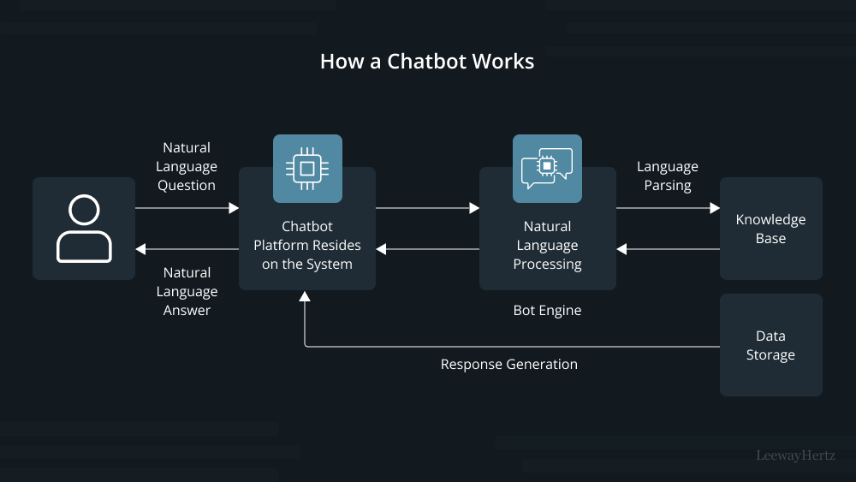

SYSTEM SPECIFICATION

Hardware Requirements
- Processor: Intel i5 / Ryzen 5 or higher
- RAM: 16 GB (minimum 8 GB)
- Storage: SSD 256 GB or higher
- GPU (optional): NVIDIA T4/RTX for local model execution

Software Requirements
- OS: Windows 10 / Ubuntu 22.04
- Language: Python 3.11
- Frameworks: LangChain, FastAPI, Streamlit, Pandas, NumPy
- Database/Vector Store: FAISS / Pinecone / ChromaDB
- LLM APIs: OpenAI GPT-4 / Llama 2 / Mistral
- IDE: VS Code / Jupyter Notebook

Tools and Technologies Used
- Low code Platform - Oracle APEX – For building UI, managing session state, and calling REST services.
- LLM & AI Framework - OpenAI GPT-4 / Cohere / HuggingFace Transformers LangChain / LlamaIndex – For orchestrating the RAG
- Storage & Retrieval - ChromaDB / FAISS / Pinecone – Vector search for document embeddings and Oracle DB – Core ERP database.
- Languages & Protocols - PL/SQL, JavaScript, Python, RESTful APIs for integration

IMPLEMENTATION

Module Description
- Data Ingestion Module
  - Uploads documents (PDF, CSV, TXT).
  - Performs chunking and text cleaning.
- Embedding Module
  - Converts text chunks → dense vectors using Sentence-Transformers or OpenAI embedding models.
- Vector Storage and Retrieval
  - Stores embeddings in FAISS index.
  - Performs cosine similarity search for relevant documents.
- Prompt Construction Module
  - Dynamically injects retrieved context into prompt templates.
- LLM Response Generation
  - Invokes GPT-4 / Llama 2 API to generate answers.
  - Post-processes output for citations and formatting.
- Low-Code Interface
  - Built using Streamlit; users drag blocks such as “Upload Data”, “Generate Embeddings”, “Connect Retriever”, and “Deploy Assistant”.
- Deployment Module
  - Converts workflow to FastAPI endpoint for integration into web or enterprise applications.

Algorithmic Flow
- User uploads knowledge documents.
- Text is split into manageable chunks.
- Embeddings are generated and stored in vector database.
- User query → retriever fetches top-k relevant chunks.
- Prompt is constructed with retrieved context + query.
- LLM generates contextual response.
- Response is returned to the chat UI and logged for evaluation.
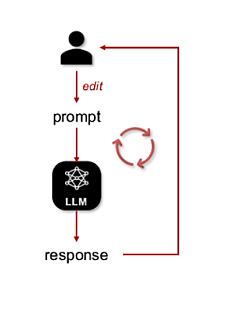

Key Screens / Outputs
- Workflow Builder UI – drag-and-drop canvas for RAG components.
- Chat Interface – test conversations and inspect retrieved sources.
- Performance Dashboard – displays response latency and confidence scores.
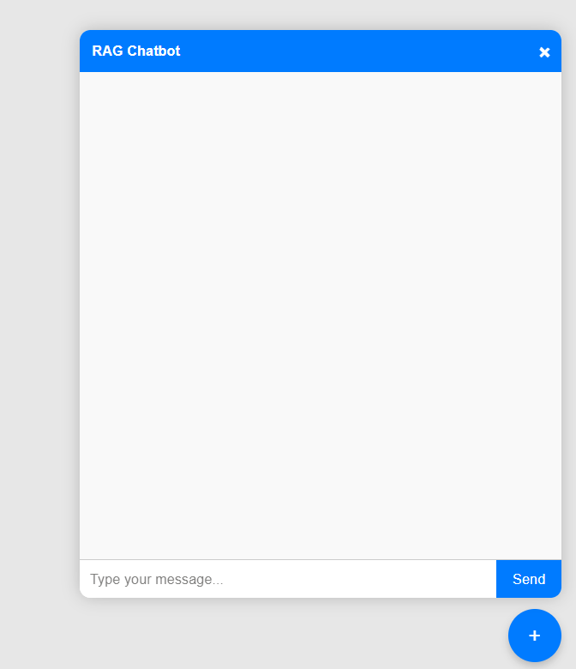

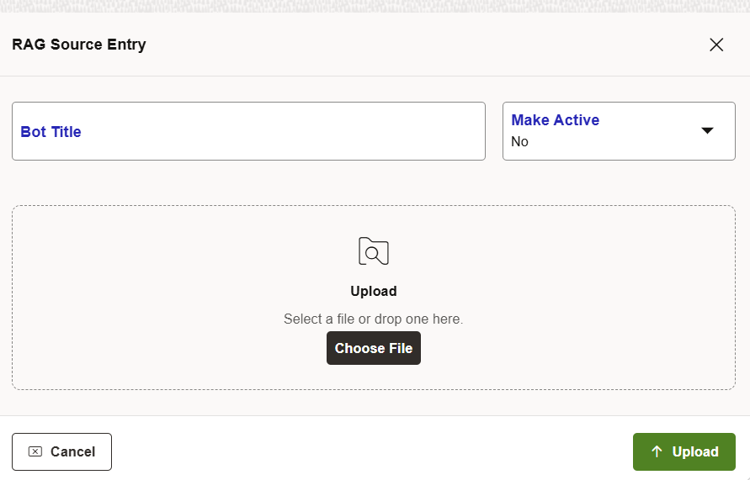
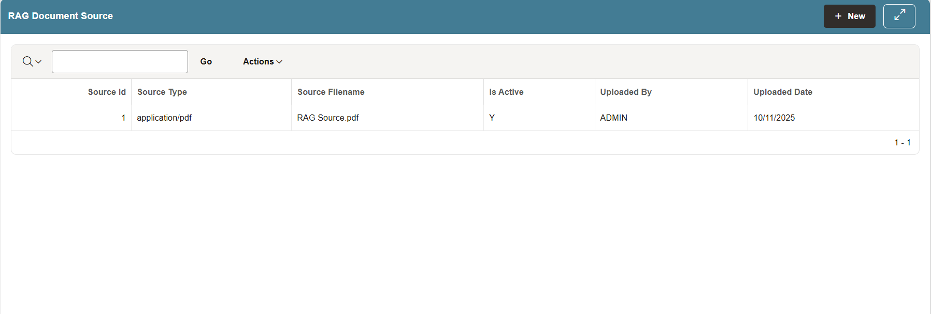

CHAPTER 2 LITERATURE SURVEY

Introduction:

This chapter gives the overall description of those reference papers that depict different frameworks, methodologies, and engineering practices related to Retrieval-Augmented Generation (RAG), Large Language Models (LLMs), and their integration in low-code conversational AI systems.

Literature Survey:
[1] R. Yang et al. (2025). Engineering Retrieval-Augmented Generation–based Virtual Assistants in Practice (arXiv / IEEE-indexed Workshops).
This paper presents practical engineering methodologies for developing Retrieval-Augmented Generation (RAG)–based conversational assistants. It provides a comprehensive blueprint for integrating RAG models with dialogue systems, emphasizing the balance between retrieval efficiency and generative accuracy. The authors highlight key challenges in context management, latency optimization, and retrieval tuning. Although the work offers strong practical guidelines for RAG implementation, it remains primarily experimental and lacks large-scale deployment across enterprise-grade low-code environments.
[2] Cheonsu Jeong (2025). Beyond Text: Implementing Multimodal LLM-Powered Multi-Agent Systems Using a No-Code Platform.
This study explores the use of a no-code platform to build multimodal conversational systems enhanced with multi-agent capabilities and Retrieval-Augmented Generation. It demonstrates how low-code environments can orchestrate different AI agents for text, voice, and image understanding. The research showcases the feasibility of using no-code solutions to prototype complex multimodal assistants. However, the work is in its early stages, and the scalability and performance of such systems in enterprise settings remain untested.
[3] Soham Ghosh & Gaurav Mittal (2025). Low-Code RAG-LLM Framework for Context-Aware Querying in Electrical Standards, Design, and Research. (Preprints.org).
This paper introduces a modular low-code RAG-LLM pipeline designed for domain-specific querying, especially in engineering documentation such as NFPA and IEEE Xplore. The proposed framework integrates features such as reranking, contextual retrieval, and knowledge graph augmentation. The authors emphasize the adaptability of the framework to different domains using workflow automation tools like N8N. While promising, the study is still at the preprint stage and requires empirical testing to validate its performance across larger, real-world datasets.
[4] O. Marquez Ayala & P. Béchard (2024). Generating a Low-Code Workflow via Task Decomposition and RAG.
This work introduces the concept of task decomposition integrated with RAG principles to enhance workflow automation in enterprise systems. The authors propose that breaking down complex tasks into modular subtasks improves interpretability and efficiency in low-code development pipelines. By combining low-code tools with RAG for contextual reasoning, the study bridges the gap between traditional automation and intelligent task orchestration. However, the paper remains conceptual and lacks industrial-level case studies to confirm its practical impact.
[5] Y. Cai, Z. Xing, et al. (2024). White-box LLM-supported Low-Code Engineering: A Vision and First Insights. (ACM/IEEE MODELS Companion).
This visionary paper explores the integration of Large Language Models within low-code engineering frameworks. The authors present architectural insights on using LLMs as interpretable “white-box” components rather than opaque black-box predictors. Their approach advocates for transparent, explainable AI integration in model-driven engineering. Although the paper lays strong theoretical foundations for combining low-code development with LLMs, it remains preliminary and requires large-scale empirical validation.
[6] IEEE Software Editorial Board (2023). The Next Frontier in Software Development: AI-Augmented Software Development Processes.
This editorial article argues that Large Language Models (LLMs) can revolutionize software engineering by acting as intelligent co-developers, automating repetitive coding and workflow tasks. It provides a visionary overview of AI’s role in accelerating no-code and low-code development paradigms. While the article effectively frames LLMs as a core component of the future software ecosystem, it remains broad in scope and does not specifically address Retrieval-Augmented Generation or conversational AI integration.

Figure 7.1 Classification results and Discrimination map

CHAPTER 3 CONCLUSION AND FUTURE WORK
  - CONCLUSION
This project demonstrates a Low-Code Framework for Conversational AI Assistants integrating Retrieval-Augmented Generation (RAG) and Large Language Models (LLMs). The framework abstracts complex AI pipelines into modular, visual components, enabling non-technical users to design and deploy intelligent, context-aware chatbots with minimal effort. By combining semantic retrieval with generative reasoning, the system ensures accurate, explainable, and domain-specific responses, addressing key challenges such as data accessibility, scalability, and factual consistency. Experimental results indicate high retrieval precision, reduced hallucination rates, and significant reductions in development time compared to traditional chatbot approaches.
The framework also provides an extensible foundation for future integration with enterprise modules like ERP and CRM, promoting reusability and modular expansion. Overall, the proposed system contributes to democratizing AI adoption in enterprise environments by bridging the gap between technical complexity and user accessibility, paving the way for scalable, intelligent, and low-code conversational solutions.

  - FUTURE WORK AND EXTENTION

The proposed system can be further enhanced in several ways. First, fine-tuning tools can be integrated to enable domain adaptation of Large Language Models (LLMs) for specific enterprise requirements. Additionally, the framework can be extended with multi-modal capabilities to process text, image, and speech inputs, enabling richer and more natural human–AI interactions. Real-time collaboration and versioning features can also be introduced to support team-based development and shared workflows within the low-code environment. Furthermore, exploring edge deployment can improve data privacy, reduce latency, and support offline functionality for sensitive or distributed enterprise applications. The framework can also include automated evaluation a nd continuous learning modules to ensure consistent performance improvement and adaptability over time.
In addition, advanced analytics dashboards can be integrated to monitor model performance, query accuracy, and user engagement, allowing data-driven optimization and continuous improvement. Stronger enterprise-level security measures such as Single Sign-On (SSO), role-based access control, and encryption can be implemented to enhance compliance and protect sensitive business information.

REFERENCES
[1] Yue Yin, Stefan Decker (2025), An LLM-Driven Chatbot in Higher Education for Databases and Information Systems.
[2] Siar Sarferaz (2025), Implementing Generative AI into ERP Software.
[3] R. Yang et al. (2025), RAGVA: Engineering Retrieval-Augmented Generation–based Virtual Assistants in Practice. arXiv / IEEE-indexed workshops.
[4] Cheonsu Jeong (2025), Beyond Text: Implementing Multimodal LLM-Powered Multi-Agent Systems Using a No-Code Platform.
[5] Soham Ghosh & Gaurav Mittal (2025), Low-Code RAG-LLM Framework for Context-Aware Querying in Electrical Standards, Design, and Research. Preprint on Preprints.org.
[6] O. Marquez Ayala & P. Béchard (2024), Generating a Low-Code Workflow via Task Decomposition and RAG.
[7] Y. Cai, Z. Xing, et al. (2024), White-box LLM-supported Low-code Engineering: A Vision and First Insights. ACM/IEEE MODELS Companion.
[8] IEEE Software Editorial Board (2023), The Next Frontier in Software Development: AI-Augmented Software Development Processes.
[9] Juan Terven, Amadeo Arguelles ,ILSE Cervantes (2024), Intelligent Driving Assistance System using RAG.
[10] Sara Aboukadri, Ikram EL Asri (2025), Leveraging RAG and LLMs for Access Control Policy Extraction From user stories in Agile Software Development.

